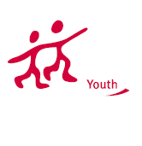
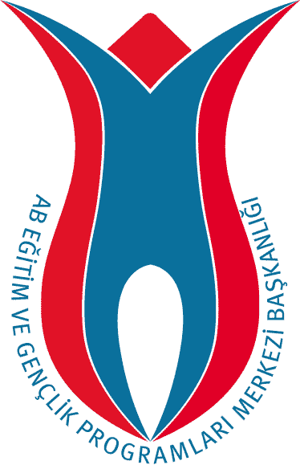
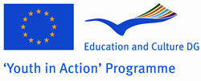
TURKISH NATIONAL AGENCY

PARTNER REQUEST FORM
Please read below before filling in the form:
1- This form should be sent to the email address: partneryouth@ua.gov.tr
2- Only forms written / typed in English is accepted.
3- To mark a check box, please double click on it and select “checked” as the default value, and click OK.
4- Please do not remove any tables or explanations.

About the Organization and Contact Person
Name of the Organisation / Group |  |  | Art and Performance Center
Address | Gosteri Sanatlari Merkezi, Mecidiyekoy Kultur Merkezi, Istanbul/Turkey
City | Istanbul | Country |  | Turkey
Telephone 1 | +90212 288 90 72 | Telephone 2 |  | +90212 288 90 73
Email 1 | kultursanat@kultursanat.org | Email 2
Fax | 0212 288 90 74 | Website
Name of the Contact Person
Telephone 1 | +90537 319 4351 | Telephone 2 |  | +9 0212 674 4611
Email 1 | seymaakkoyunlu@gmail.com | Email 2 |  | seymaakkoyunlu@hotmail.com

2. About The Project
Project Name: |  | Youth on Stage

Type of the Project
 | Action 1.1 - Bilateral |  |  | Action 1.1 -Trilateral |  |  | Action 1.1 - Multilateral
 | Action 1.2 - Transnational |  |  | Action 1.3 – Youth Democracy Projects |  |  | Action 3.1 – Youth Exchanges
 | Action 3.1 – Training & Networking |  |  | Action 4.3 |  |  | Action 5.1

If It is Action 4.3 or 3.1 Training & Networking, then the Activity No:

(1- Job Shadowing, 2- Feasibility Visit, 3- Evaluation Meeting, 4- Study Visit,

5- Partnership-Building, 6- Seminar, 7- Training Course, 8- Networking)
Activity venue/place |  |  | Istanbul |  | City |  | Istanbul
 |  |  |  |  | Country |  | Turkey
Activity start date |  |  | 01. / .02. / 2010..(due to change) |  | End date |  | 08... / ..02. /2010. (due to change).
Aim and Objectives
Our project is a combination of cultural interaction, self-expression through performing arts, youth politics in each participant country and in EU in general. As a team of young actors, our goal is to articulate the problems and advantages of being young in our countries. We will utilize the power of arts in expressing ourselves on a theatre stage. We will also encourage each other to develop the art of public speaking. We will touch each others’ lives by sharing our experiences as a young person at school, home and work. We will also let our guests to convey us their experiences of being different in Turkey through different, innovating and inspiring activities. Another goal of this project is to raise awareness on youth politics in EU in general and to discuss how participants want their country to develop youth politics and how they plan this to happen.
Planned activities
Theatre workshops
Theatrical performance
Scriptwriting
Involvement in group activities enabling cultural interaction (Shopping at an open air market , playing percussion in a professional team(okay temiz), playing table tennis and bowling)
Learning simple and introductory foreign language
Giving free speeches on stage regarding young peoples’ feelings and thoughts on life and youth politics
Discussions on youth politics in EU and in each participants’ country in particular
Visits to youth clubs in universities and engagement in constructive dialogue on common youth problems and advantages of being young.
Through the activities listed above establishing friendship and cooperation for future projects

3. About The Group / Participants
Gender Balance | Male |  | Female | Total
Gender Balance | 5 |  | 5 | 10
Age Range | 13-14 |  | 15-17 | 18-25 |  | 26-30
Age Range |  |  |  | 18-25
General Profile of the Group |  | Young people |  |  | Unemployed young people
General Profile of the Group |  | Students |  |  | Youth workers
General Profile of the Group |  | Apprentices /young workers |  |  | Ethnic minorities
General Profile of the Group |  | Disabled |  |  | Disadvantaged youth
General Profile of the Group |  | Youngsters with special needs |  |  | Other

4. Which countries would you like to have partner from?
Our project is open to all program countries
Our project is open to all program and partner countries
I would like to write the list of countries (separated by comas):

5. Any Additional Information

